

Travlr Getaways Website

CS 465 Project Software Design Document
Version 1.2

Table of Contents

CS 465 Project Software Design Document 1
Table of Contents 2
Document Revision History 2
Instructions 2
Executive Summary 3
Design Constraints 3
System Architecture View 3
Component Diagram 3
Sequence Diagram 4
Class Diagram 4
API Endpoints 4
The User Interface 4

Document Revision History

Version | Date | Author | Comments
1.0 | 05/24/26 | Scott Weiss | Completion of the Executive Summary, Design Constraints, and Component Diagram sections.
1.1 | 06/07/26 | Scott Weiss | Completion of the Sequence and Class Diagrams, and the API Endpoints sections.
1.2 | 06/21/26 | Scott Weiss | Completion of the User Interface section.

Instructions

Fill in all bracketed information on page one (the cover page), in the Document Revision History table, and below each header. Under each header, remove the bracketed prompt and write your own paragraph response covering the indicated information.

Executive Summary

The client, Travlr Getaways, has requested a fully functioning website that will include full stack web application that will consist of an admin single-page application (SPA), a database, and a customer-facing website. The full stack application will end up using the MEAN stack which consists of MongoDB, Express, Angular, and Node.js.

The customer-facing part of the application will be a user-friendly webpage that will allow the customer to move around and view various parts of the website. The single-page application that will be used by the administrator will use Angular, and will allow data to easily be modified as needed.

Design Constraints

A design constraint of sticking strictly with the MEAN stack means sticking with it's limitations. For example, MongoDB, which is used as the database aspect of the MEAN stack, has a limitation where the document size is restricted to a maximum of 16 MB. (MongoDB Limits and Thresholds, n.d.) While it should be adequate for this current project, should the need arise in the future for the client to need larger sizes, the design must be worked around its current limitation.

Another limitation is in Node.js, where it uses a single-threaded model. The main constraint in this is ensuring the code is designed well and that the necessary processes do not interfere and bottleneck the overall function. "Similarly, if your central process is responsible for reading each static file (such as CSS, JavaScript, or images), it won’t be able to process any other request, thus blocking the flow." (Holmes & Harber, 2019) Ensuring initial proper design will be essential to optimal flow.

System Architecture View

Component Diagram

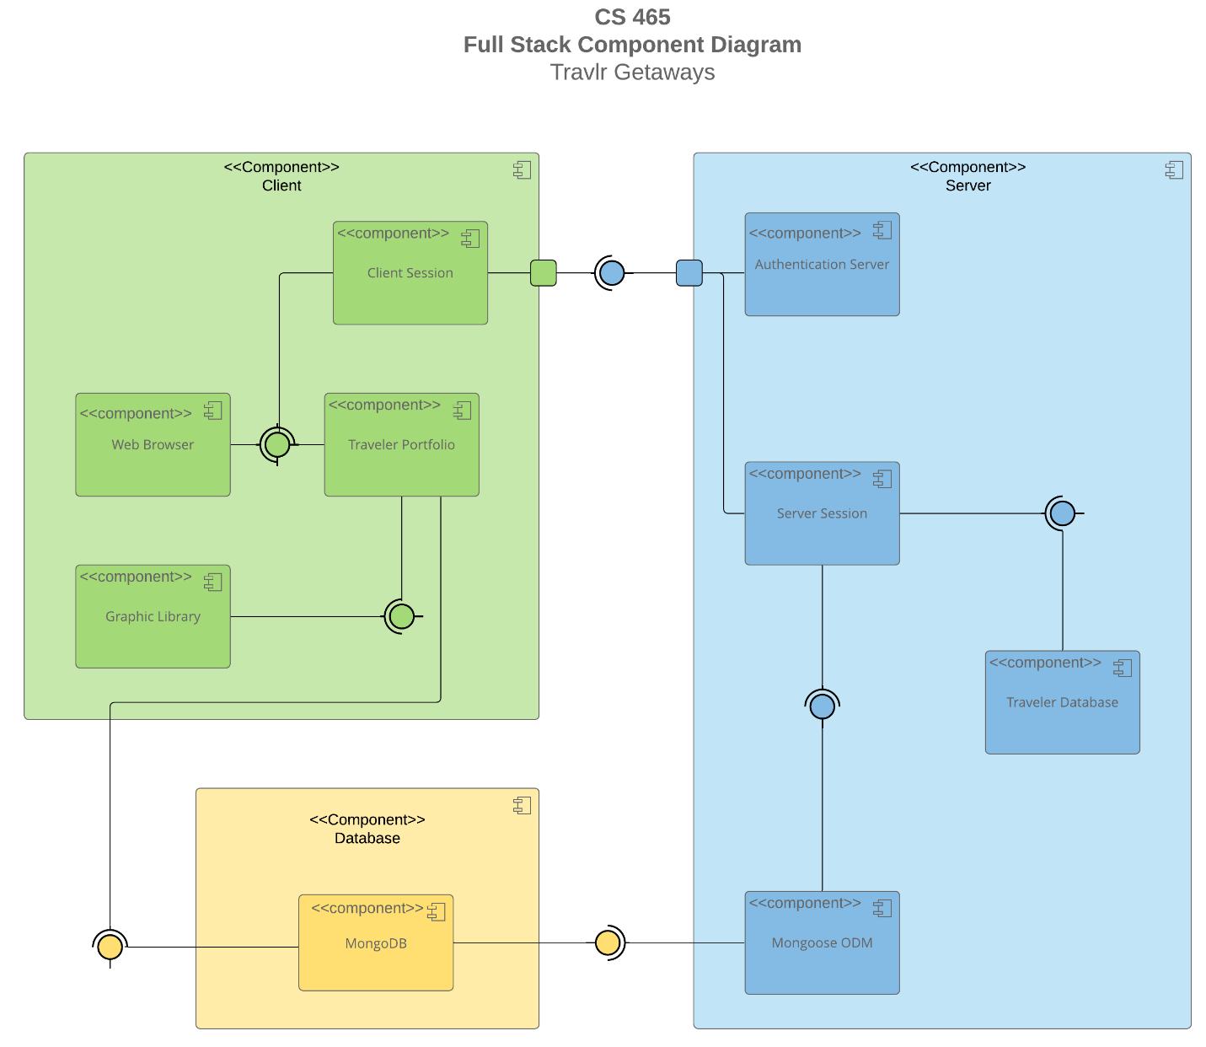Image 1: Component Diagram

A text version of the component diagram is available: CS 465 Full Stack Component Diagram Text Version.

Image 1 above shows what is the component diagram for the overall architecture behind the Travlr Getaways web application. In the top left is the client component, which will be the front-end part of the application that will use the Angular part of the MEAN stack. This main component will contain its own smaller components such as the initial client session and utilize other components such as the graphic library to pull from for the web browser. The front-end will communicate through required interfaces with other main components like the database component using Express, another aspect of the MEAN stack.

The server component will be the main back-end of the application, and will manage various aspects such as authenticating and managing the server sessions. The server will utilize Mongoose Object Data Modelling (ODM) that will provide a way to perform various operations for both MongoDB and Node.js. The database component holds the MongoDB database part of the MEAN stack that will house all of the necessary files that the site will use, such as images or travel package information. The MongoDB component will serve both the front-end and back-end components of the application.

Sequence Diagram

Image 2: Sequence Diagram

The sequence diagram, shown above in Image 2, displays the flow of the web application through the client-side, to the server-side, with the data-tier, and then back again.

On the client-side, the actor being the client would go the website as the Route tier which would redirect the actor to the Browser/View/Template tier. In this tier, the user may do certain actions such as wish to sign in or book a trip. This would cause the Browser/View/Template tier to interact with the controller to then make that request through the HTTP Client tier to get information from the database further in the sequence.

On the server-side, the Route would call on the Controller/Model to retrieve and check necessary information from the Data-Tier. Using Mongoose to interact with MongoDB and process the information request, this information would then be sent back to the Controller/Model tier to the start sending back the information back along the sequence. Once the Route sends the information back from the server-side to the client-side in the HTTP Client tier, this would send back to the Controller to then display the information in the Browser/View/Template tier for the actor to view on the website.

Class Diagram

Image 3: Class Diagram

Looking at the class diagram in Image 3 shown above, it displays a variety of various classes that interact with each other with their own unique attributes or methods.

Starting with the Travel_Agent class, this class interacts with almost every other class in order to process trip and traveler information through its methods, using itinerary information. All methods, such as BookFlight, BookHotel, and BookCruise, use information from their appropriate classes, being FlightInfo, HotelInfo, and Cruise Info, with BookPackage using Itinerary class information for overall booking. The Travel_Agent class can have many relationships between each Booking class (HotelBooking, FlightBooking, and CruiseBooking), as there can be many bookings that can be implemented. The Travel_Agent class as well interacts with the TravellerInfo class in order to make said bookings.

The TravellerInfo class has one main attribute, being the companionnum attribute. This class is used to pull information to be used in the Booking classes (HotelBooking, FlightBooking, and CruiseBooking), as well as being a subclass of the superclass MemberAccount, as it inherits information to be used for other means. The MemberAccount class has various attributes to store the traveler’s member info and is a child class to the parent class of Membership_Admin, which has appropriate methods using the MemberAccount attributes to get necessary membership information.

The CruiseInfo, FlightInfo, and HotelInfo classes all have their own specific attributes for storing appropriate information such as names and prices of their own information to use for booking, which all three classes are subclasses of the superclass TripInfo, which has its own attributes for the traveler's trip information. The three Info classes are subclasses of the Itinerary class, for the info shown to be applicable to the traveler's desired trip.

The HotelBooking, FlightBooking, and CruiseBooking classes all have one method each for their own unique booking, using information from the TravelerInfo and appropriate Info classes to get necessary information.

API Endpoints

Method | Purpose | URL | Notes
GET | Retrieve list of all trips. | /api/trips | Returns all trip entries in the database.
GET | Retrieve a single trip. | /api/trips/:code | Returns a single trip using the code for the desired trip.
POST | Create new trip. | /api/trips | Create a new trip into the database.
PUT | Replace existing trip. | /api/trips/:code | Replace existing trip information using desired trip code.
PATCH | Update existing trip. | /api/trips/:code | Update existing trip information using desired trip code.
DELETE | Delete existing trip. | /api/trips/:code | Delete existing trip entry in the database using desired trip code.

The User Interface

Image 4: Add Trip with Trip Data

Image 5: Add Trip Successful

Image 6: Edit Trip Screen with Trip Data

Image 7: Using Postman PUT to Update Trip

Image 8: Trip Successfully Updated

With using the Express project structure, it's a bit more limited as to the features it can offer. In itself it does have many uses, such as if one would wish to access and serve static files for a web browser or using it for smaller apps, however it's a much simpler configuration. Angular project structures, such as that utilized for this Single Page Application (SPA), is more dynamic in that it can aim to provide higher end functions as it supports more interactive features. In this case, allowing the user to add and edit trips securely. One advantage with SPA functionality is that it creates less load on interactions between client and server. With having the app render be done client-side, it allows for more ease on the server. A disadvantage might be that load times may be initially longer.

Testing the SPA from multiple angles was helpful, using both the add and edit features added into the admin page as well as using Postman to GET and PUT data, while using the MongoDB Compass application to ensure any changes were successfully implemented in the database.

References

Holmes, S., & Harber, C. (2019b). Getting MEAN with Mongo, Express, Angular, and Node (Second Edition). Manning Publications. https://learning.oreilly.com/library/view/getting-mean-with/9781617294754/

MongoDB Limits and Thresholds. (n.d.). Database Manual - MongoDB Docs. https://www.mongodb.com/docs/manual/reference/limits/?atlas-provider=aws&atlas-class=general

